2446532

Max kruger

Design Document

**Genre/SubGenre analysis**

A 2D Shooter is a subgenre of action video games where the main focus of the game is almost entirely to defeat enemies of the playable character using weapons given to the player. I have used space invaders and Enter the Gungeon as inspiration to my games. Space Invaders is also categorized into the shoot ‘em up subgenre which is a subgenre of shooter games but is classified by player movement and camera angles. Space invaders lets players move left, right, up and down and has a fixed camera. Enter the Gungeon is of the bullet hell or manic shooter subgenre where players defeat hordes of enemies. Enter the Gungeon also uses a top down camera angle that follows the player. Camera angle, movement and gameplay is what separates these 2 genres. The core mechanic of Enter the Gungeon is shooting with a few other mechanics that aid in bullet hells such as a dodge and what the game calls a “blank” that gives you space when things get too overwhelming in the moment. Space invaders also uses a shooting mechanic as its core mechanic. Instead of a dodge however it uses a cover system that allows players to hide behind the cover to not take damage from enemy bullets. However if enemies get too close then they will erase the cover forcing players to peek out and take risks. Overall space invaders feels more like a race compared to Enter the Gungeon and in this document I will explain how I took inspiration from both of these games. Enter the Gungeon is also a roguelike with randomized levels. A Roguelike is a subgenre of a Role-Playing video game that includes dungeons and randomized levels.

**Design Goal and Interrogation**

My vision for my game was to create a semi-open world bullet hell game with a space invaders theme. Most bullet hells are rooms or arenas that you enter with hordes of enemies attacking you. The exception to this is a game like Diablo that has a similar design to a semi-open world game.

Bullet hell games instantiate enemies on the fly depending on a timer or a player's position which increases performance of the game. Games like Diablo instantiate enemies once the play has spawned in. I went for a diablo style enemy spawner which was challenging because I never wanted the player to feel like they were at rest, but rather constantly under tension. Creating a semi-open world was hard because the enemies spawned on fixed positions as soon as the player clicks play. This meant that the player had to approach the enemies. Another challenge for me in my design goal was that I wanted the game to become progressively more difficult. And like diablo the most challenging encounters are the boss fights. I wanted to challenge the player to have to constantly think about where they are and how they move while trying to kill enemies. I think I successfully did that by mainly using projectiles that the player has to dodge. Moreover to make the game more interesting for the player I added 2 abilities. Again similar to what you would find in Diablo. Players can use these abilities strategically to make encounters easier for themselves. Abilities are not always in bullet hell’s, usually it's a dodge mechanic like in Enter the Gungeon, however, they have many different weapons which keeps the game fresh and engaging. In my game these abilities and enemy variety keep the game fresh with a new type of enemy popping around every corner. In order to achieve my semi-open world I had to make the so-called “bullet hell arenas” exceptionally large and crawling with enemies to make sure it fits into the genre. The challenge was in making sure that players had minimal time to rest which meant that every corner of the open space had to have something dangerous and threatening to the player. I think I have achieved this with the combination of my objective arrow which points in the direction the player must move. This forces players to have to approach enemies in order to achieve the player's objective and creates a constant stress for the player.

I experimented with the theme of space invaders since space invaders is not an open world game by any means, plus space itself is an extremely large open space which played well into my goal of a semi-open world. In my second level I wanted the player to be inside of an enemy ship which is much more roomy than space but still managed to make the ship feel large enough as to not go against my semi-open world goal.

**Design Process**

My initial Idea in my game was to have 2 semi-open world areas that players play in. Because of this I also wanted my game to be linear and to go from objective to objective. These objectives are seen as these golden balls and arrows that point to what the player has to do or where the player must go. See next page:

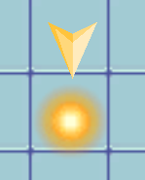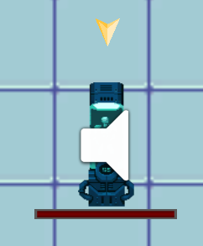

The gold balls indicate that the player must move there to complete their objective and the other one indicates that the player must destroy that object (as seen by the health bar). Another useful tool that I used is an objective arrow that surrounds the player indicating to the player where they must go if the objective is not in the camera view. Refer to image below.

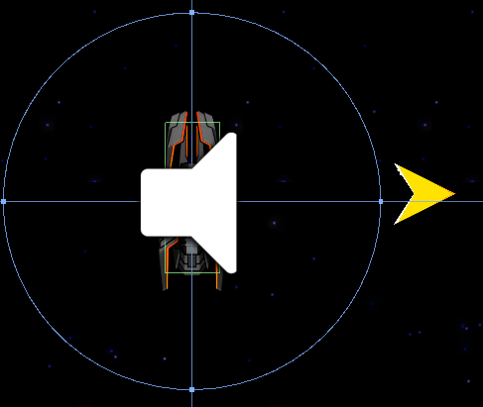

This was my first task as I have been wanting to work on questing and objectives in my games since they have been lacking for a while now.

I then wanted to get working on the base enemy types so that when I created my levels it would be easier to just sprinkle my different enemies and their varying difficulties where I wanted the game to feel more difficult and where I wanted them to be easier.

Here is a few of them:

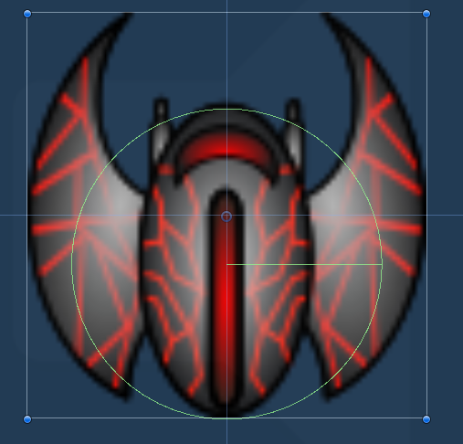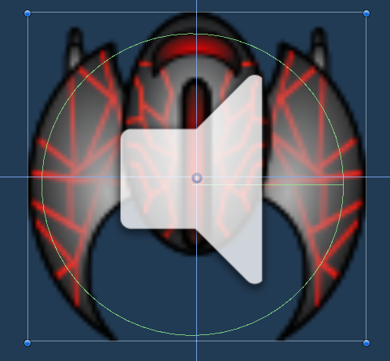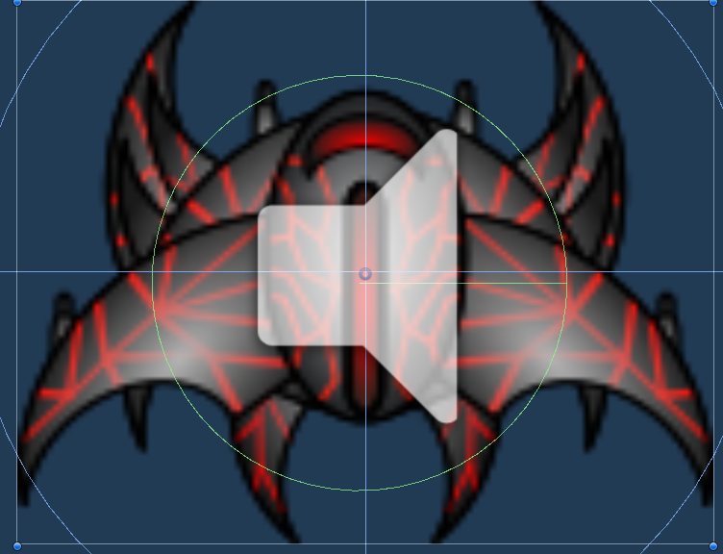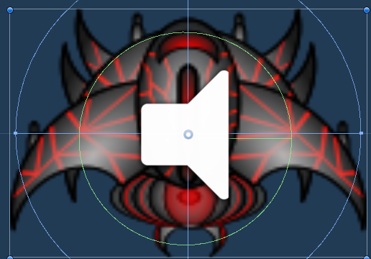

Check out my Spreadsheet to get an Idea of the different enemies health and damage calculations:



This allowed me to create varying enemy bullets that were colour coded and did different damages. Some were quicker than others to really challenge the players movement and dodging ability.

After I had created the enemies and player with a basic shooting mechanic for both I felt that the game was too bland and needed more of a skill gap for the player to explore in. I had the idea of having a shield for the player and maybe a missile of some sort. This was challenging since I had never used cooldowns in a game before but to my surprise it was much easier than expected. So I created them as Q and E abilities. The norm in games such as Diablo and League of Legends is to have your abilities set to Q, E, R and any other keys nearby the movement keys. See Image s Below:

With Cooldown:

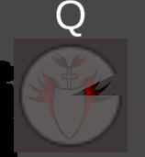

Without:



This was a clear indicator to the player on whether or not their ability was ready to use or was still in cooldown.

Now that the game felt more interesting and had the core components of a bullet hell 2D shooter I needed to create the levels with progressive difficulty. Plus I wanted to add at least 1 bossfight.

Here is the basic linear layout:

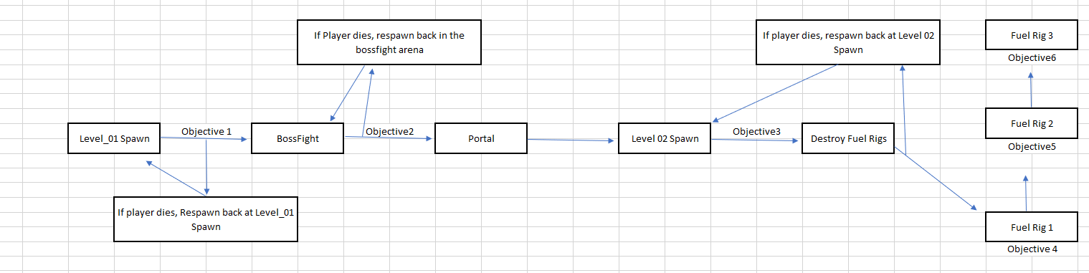

At the end of level 1 players are enclosed in a boss arena where the boss has 2 varying attacks and often spawn minions on the battlefield to pressure the player more and more as the bossfight goes on. This was tricky to balance but if the player uses their abilities enough and efficiently and manages to dodge between the bosses bullets then they should be fine. I won't spoil the bossfight with an image here but do enjoy the tension when you play.

Level 1 is a very open area in space, literally. I wanted players to really feel the space invaders theme that I have tried to implement. I also tried my best to put a bunch of different audio sources and my very own voice lines to immerse the player into the feeling of what it is like to be on a space mission. This was quite fun. Level 1 really commits to my idea of a semi-open world game while at the same time tying into the idea of a linear game using objective arrows.

At the end of level 1 players enter a portal that puts them in an enemy ship where the difficulty increases. Their main mission is to destroy 3 fuel rigs scattered around an open area in the enemy ship. Players must always be on the move since there are much more dangers in the area. More enemy ships, more bullets to doge and with a cherry on top I added mines that if the player walks onto they take a bulk of damage.

See Mine Image below:

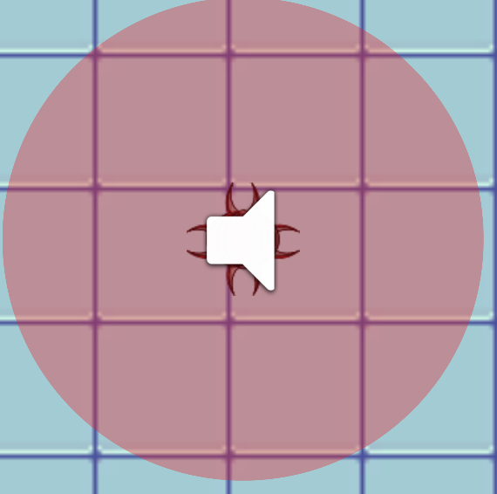

These mines that are sprinkled throughout the level were a great way to combat the movement of the player. Skilled players are usually able to dodge almost all incoming enemy projectiles but the mines limit their movement so players are forced to eliminate their enemies rather than avoid them. However this created a problem. When I playtested this, I tried the second level at least 10 times and everytime would find myself easily overwhelmed by enemy projectiles with nowhere to go. I thought long and hard on this and how I could balance this out but then it came to me. In space invaders, players have cover that they can hide behind to prevent getting hit by enemy bullets. I thought that this was a great idea. So within this open area there are large blocks of cover that players can maneuver around to prevent themselves from being overwhelmed. There was 1 more problem with this level. It took me an average of 3 - 5 minutes each time to complete this level in which I would run out of ammo way too often. I decided to put a lot of ammo and health pickups around these blocks not only to give players resources but to encourage players to use these blocks as cover when they need it.

See Image Below:

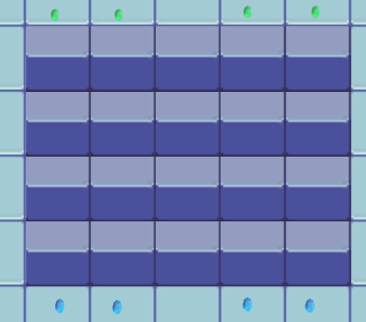

**Reflection**

My goal for this project was mainly to learn how to use projectiles, Transforms and different enemy types. My focus was of course to create a semi-open world bullet hell but in the process I learned a lot.

I am a coder, I love programming and it gives me satisfaction to create something that works. Usually going about an assignment includes so many videos on how to do this or that. But this time I really tried to not get help but rather to learn from all of my previous projects. While creating this game I quickly realized how I was able to create things so much faster than before without even thinking about it too hard. Things that I previously found difficult were suddenly easy to me and felt like second nature. This was an amazing feeling because I really put my all into this project. 90% of the games I play are shooters, I simply love them, and when I saw we were going to be making a 2D shooter I was so happy and ready for the assignment. This was by far my most successful project and it was also the most fun I have had in making a game.

During the process of making this I found 3 things that were very important to me when making a bullet hell game. Number 1 was movement. In all bullet hells movement is very important and aids the player in survival. I needed the player to be moving constantly which is forced through enemy projectiles being flung at the player every second. Number 2 was some sort of skill. If the player just shot the same weapon or ability throughout the whole game the game becomes stale and players quickly feel bored. This is why I created 2 abilities for the player to use strategically. And number 3 is the element of surprise. Whether the surprise is a new weapon, ability, enemy type or level. Players need to feel engaged and constantly put to the test. This is what makes a bullet hell game fun and worth experiencing. In my game I have different enemy types that seem to pop up out of nowhere and players get used to them and are quickly able to adjust themselves to beat them.

Creating a semi-open world was fun but challenging. I needed players to be under tension at all times and most open world games have more resting moments than tens ones. I tried to challenge this by sprinkling more enemies in open areas where the player might try to explore. I also managed to achieve linearity by using an objective system that forces players to approach enemies near their objective.

Overall I feel that I have successfully created an semi-open world environment that has bullet hell systems at its core forcing players to use all of their resources at their disposal to complete a linear objective system. I have also thoroughly enjoyed creating a space themed game which actually wasn't my initial take on my theme but I quickly fell in love with it. I have experimented with my code to try and create difficult enemy types but none that are too special and out of order for a 2D space shooter. Furthermore I have tried using more audio in my game than with any other project. Audio is usually a very underrated aspect in games and so I have focused much more on it with this game. Moreover, modern 2D shooters use voice lines to help players feel immersed and aid in their objective focus. I decided to not use text in my game that may stray the players focus from battle but rather incorporate my own voice lines that players listen to that may aid them better than text that takes over the screen space.

I do think that I could have improved upon the boss battle by making different stages that lets the boss use more than 2 different attacks. Thus using the element of surprise and creating more of a challenge to the player.

Exam Process Addons

When I heard about the exam being an extension of one of our assignments I knew immediately that I wanted to keep working on my 2D shooter. Firstly I was happy with my first 2 levels that were already implemented so I wanted to add another level that included a more difficult boss fight, at least 2 different enemy types, and some sort of small puzzling that would force the player to have to think. Although thinking is not always a part of bullet hell games I wanted to explore the possibility that there might be space for some minor puzzle in my bullet hell game.

I first started with varying enemy types since the player was already too familiar with the enemy ships. Plus all of my existing enemies just shoot 1 or 2 bullets at the player. To make players more thoughtful about which enemy should have their attention first I created the slime enemy. The slime enemy runs at the player and once they are close enough they do small damage bits every frame so if the player is caught in a corner or just sleeping then they would take a lot of damage. This forces the player to have to focus on the slime enemies running at them before focusing on the ranged enemies. Something that I recently realized about the genre of bullet hell games is that players subconsciously focus on the enemies closest to them (mostly melee enemies) and I wanted to take advantage of that with my last level and boss fight.

After my slime enemy, I wanted to create a mini puzzle. Nothing huge but something that must make the player think. I took inspiration from a Souls-like game where toxic gas would do damage over time to players if they sat in it but they could deactivate the mist if they found the source and destroyed it. So I created these blood balls with mist attached to them that cover certain rooms. If the player destroys the blood ball then the mist disappears. Or if players don't destroy the blood ball then they will constantly take damage. Here is what they look like.

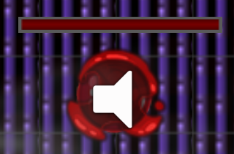

This enabled me to create situations where the player would have to look for the ball in another room to gain access to a certain path that leads to the boss fight. Sure players can just go through the mist but will be punished through damage for it.

The level design for my final level is 6 different rooms and a boss room all connected so that players can explore and solve the minor puzzle. I came across a realization though when making these rooms and it was what was the reward for players exploring these different rooms. I have 2 normal crystals that players can pick up. You can find them scattered across the world or they have a chance to drop when enemies die. First is a green crystal that gives the players health when picked up, second is a blue crystal that provided 50 ammo, and now as a reward for exploring the rooms I have provided a golden crystal that gives the player full health and ammo when picked up.

For the final piece of my last level, I wanted a difficult boss fight. Unlike the first boss fight in the game where there is 1 boss, I created 2 large bosses that you must fight consecutively. Both bosses are the same. I wanted his attacks to feel more interesting both with animations and mechanics. Firstly I made sure that the 6 bullets they shot at the player made a hexagon so players would have to properly dodge them. With the addition of 2 bosses, this meant that sometimes 2 hexagons would be shot at the same time and the player would have to dodge them both. This is difficult. The second ability is just a large slouch of blood that is shot at the player that is easy to dodge and provides a break for the player to find golden crystals and get their health and ammo back up. The final ability is where the bosses each spawn 4 slimes underneath them that chase the player. This shifts the player's focus on the boss and forces them to shoot the slimes. Overall this also makes the boss fight longer.

With regards to the slime spawning ability for the bosses, I had a problem where the slimes were too slow for the player to really feel the need to focus on them. After playtesting I was able to easily just go in a circle around the boss to avoid the slimes and just focus on killing the boss. I decided to create a public variable for the enemy's speed so that I could quickly adjust any of the enemy's speeds according to their needs. After changing the slimes speed to be much faster it leaves the player no choice but to focus on the slimes. Since they constantly follow the player they are always between the boss and the player so they act as shields for the boss.

Image of Slimes and Boss interaction:

